8/12/2024

Computer networks Lab assignment -2

Done by,   
**Sathvik S Desai  
RA2211003050051  
III-Year ‘C’**

**LAB 2: IMPLEMENTATION OF NETWORK TOPOLOGIES**

**Objectives:**

To demonstrate the straight through cabling by designing LAN, MAN, WAN and Hybrid.

**Addressing table:**

PC0 – IP Address 192.168.10.1

PC1 – IP Address 192.168.10.2

**Procedure :**

**Step1:** Drag 2 PCs and switch in the console area.

**Step2:** Select Connectivity & Copper Straight-Through Cable.

**Step3:** Click on switch to get the interface options and select Fa0/0.

**Step 4:** Now PC0 and switch are physically connected. Again select copper straight-through cable and again click on switch to get the interface options and select Fa0/1.

**Step 5:** Click on PC1 to get the interface options and select Fa0/0.

**Step 6:** Now the PCs are physically connected through switch. To establish logical Connectivity.

* Click on PC0
* Select Desktop tab
* Click on IP Configuration icon.
* Configure the IP Address 192.168.10.1 and subnet mask 255.255.255.0
* Repeat the same procedure for PC1 and configure the IP Address 192.168.10.2

Step 7: Now both PCs are physically and logically connected. To check Logical Connectivity,

Click on PC1

Select Desktop tab.

Click on Command Prompt icon.

Type ping 192.168.10.1 to fetch the output.

Step 7: Now we have to implement the different types of Network Topologies

Screenshots:

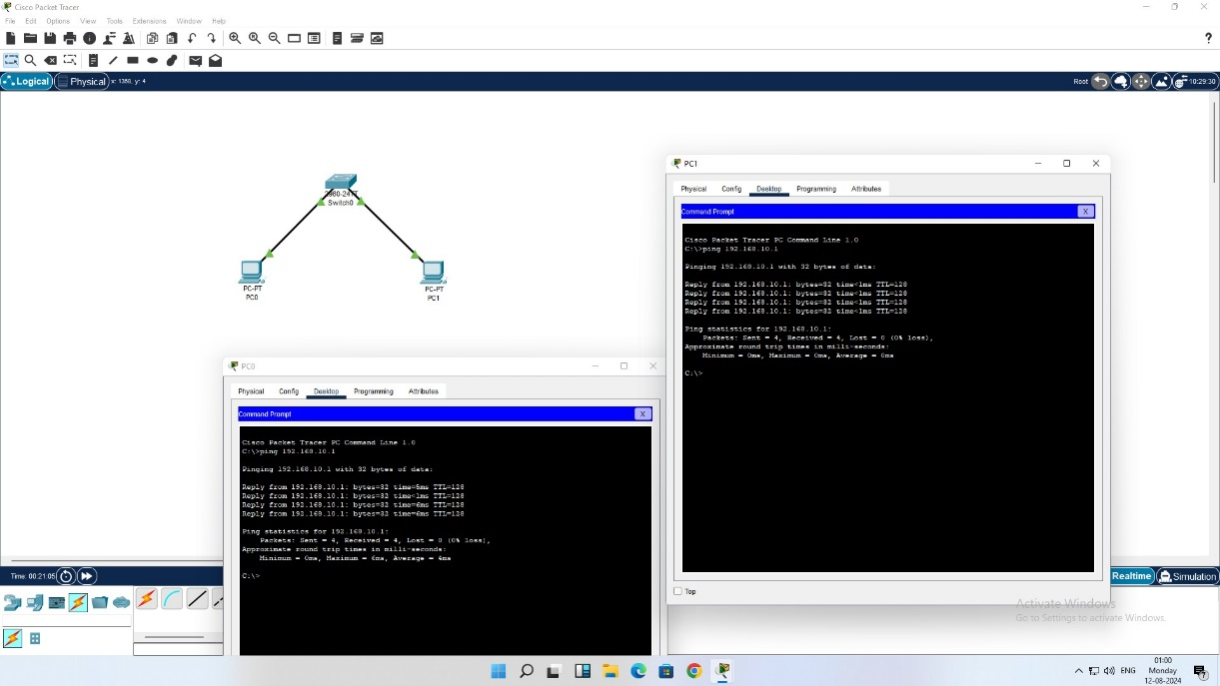

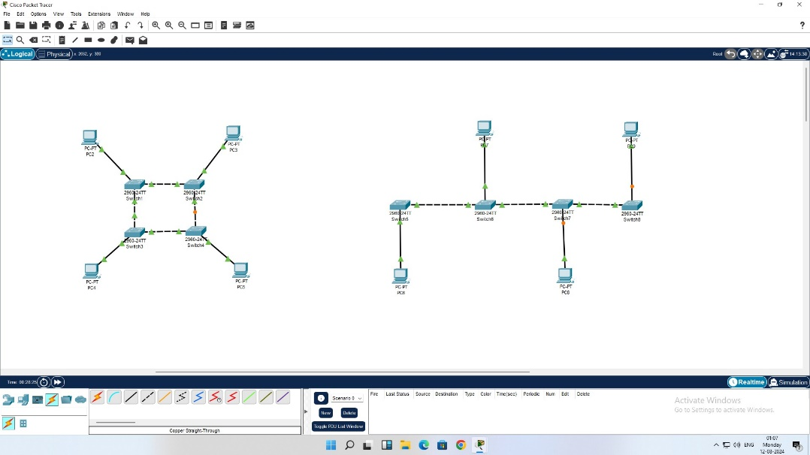

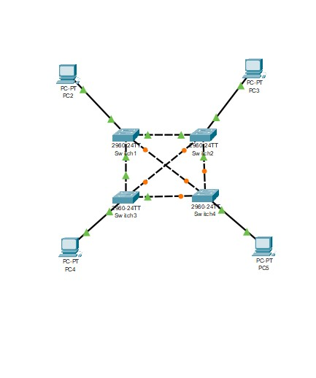

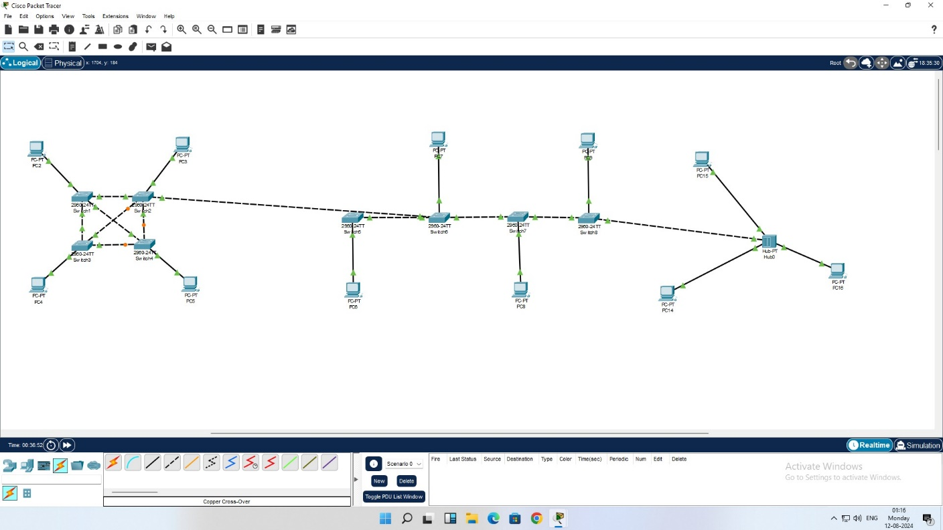

Result:

Thus, the demonstration of Network Topologies is done successfully.